The goal of this document is note down all data cleaning for the DDoc Inventory, with their reasons behind them.
NOTE:
- When the “Proj.DDoc Volume” column is readded, its value(s) were copy and pasted across all rows to allow its value to be displayed when filtering through differing batches/dates in Power BI. Should a sheet be small enough for all batches/date remain the same, only 1 copy will be necessary.
- “Status” and “Remarks/Notes” were removed as they are comment-based data, with “Month” being redundant as it’s already fully present within the “Date” column.
Agency 36
- Removed “DDoc Issue(s)”, “Additional Remarks”, “Returned”, “Month”, “Start/End Date”, “Box/Envelope”, “Agency” and “Received/Returned DDoc Volume” columns.
  - The first three columns are comment-based and cannot be analyzed.
  - “Start/End Date” is unnecessary as it will be reflected in the “Date” column.
  - “Received/Returned DDoc Volume” can already be calculated through Power BI.
  - “Box/Envelope” are generally IDs.
  - “Agency” can be written ourselves.
- Unmerged “Date” and “Batch” columns.
- Added “Unspecified” to empty “Sample Checked” rows.
- Readded the “Proj.DDoc volume” column.
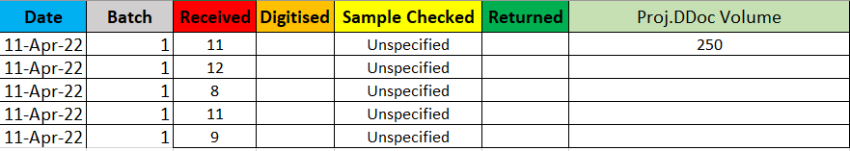

Agency 35
- Removed “DDoc Issue(s)”, “Additional Remarks”, “Box/Envelope”, “Start/End Date”, “Received/Returned DDoc Volume”, “Agency” and “Remarks” columns.
- Readded the “Proj.DDoc volume” column.
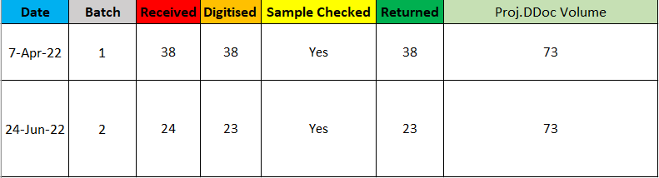
Agency 34
- Removed “Month”, “Box/Envelope”, “Start/End Date”, “Received/Returned DDoc Volume”, “Agency” and “Remarks” columns.
- Unmerged “Date” and “Batch” columns.
- Readded the “Declared Figures” column and renamed it to “Proj.DDoc Volume”. (There was no need to copy and paste its values as there is only 1 batch to filter from.)
- Added “Unspecified” to empty “Sample Checked” rows.
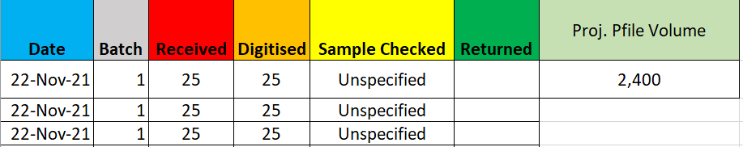
Agency 33
- Removed “Month”, “Box/Envelope”, “Start/End Date”, “Received/Returned DDoc Volume”, “Remarks”, “Additional Remarks”, “Agency” and “DDoc Issues” columns.
- Unmerged “Date” and “Batch” columns.
- Readded the “Proj.DDoc volume” column.
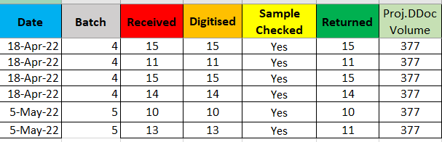

Agency 32
Due to the two unique types of records present, Vendor V and Vendor D, they will be split into two separate sheets, being Agency 32_Vendor V and Agency 32_Vendor D for easier editing. They will be all merged again at the end of this section.
Agency 32_Vendor V
- Removed “Month”, “Date”, “Box/Envelope”, “Agency”, “Start/End Date”, “Received/Returned DDoc Volume”, “DDoc Issue(s)” and “Additional Remarks” columns.
- Renamed “100%” to “Yes” for consistency.
- Added “Unspecified” to empty “Sample Checked” rows.
- Readded the “Proj.DDoc volume” column.
  - For consistency, this value will also repeat in the Agency 32_Vendor D file.
- Unmerged “Date” and “Batch” columns.
- Since we do not know the contents of each Received/Digitised/Returned files individual Box/Envelope per batch, (74 spanning over 1 of 4 and 2 of 4, etc instead of 34 and 40, 60 and 14, etc), we will simply unmerge this cell and delete the extra cell(s) below, leaving behind only 1.
- Added a “Category” column which specifies their label of data. In this case, it is “Vendor V”.
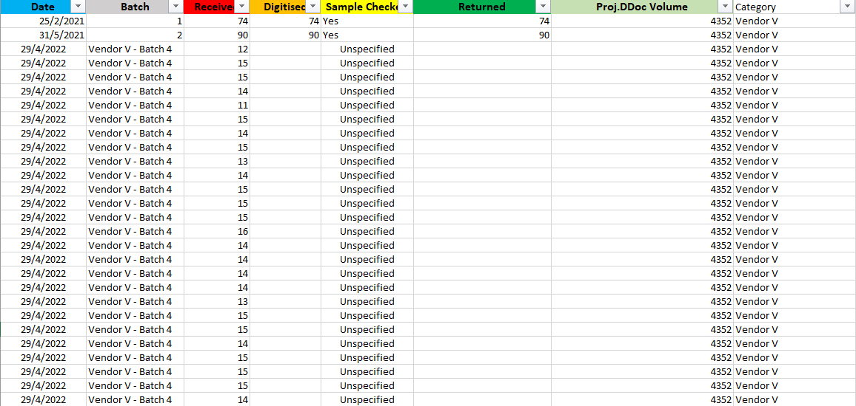

Agency 32_Vendor D
- Removed “Month”, “Date”, “Box/Envelope”, “Agency”, “Start/End Date”, “Received/Returned DDoc Volume”, “DDoc Issue(s)” and “Additional Remarks” columns.
- Readded the “Proj.DDoc volume” column.
- Renamed “100%” to “Yes” for consistency.
- Added “Unspecified” to empty “Sample Checked” rows.
- Added a “Category” column which specifies their label of data. In this case, it is “Vendor D”.
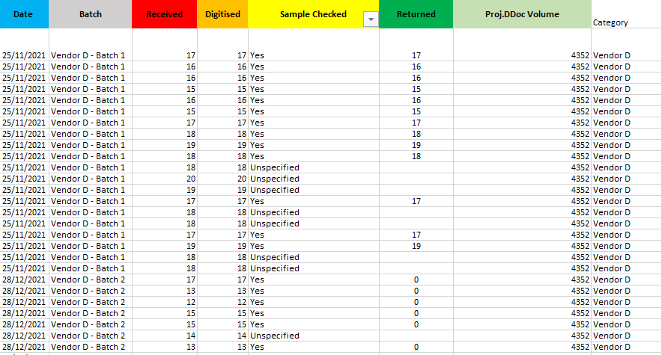

Final Merged Version
This screenshot is to confirm that all datasets have been merged in the “Agency 32” sheet, as shown in the rightmost column that contains all categories (Vendor V and Vendor D)
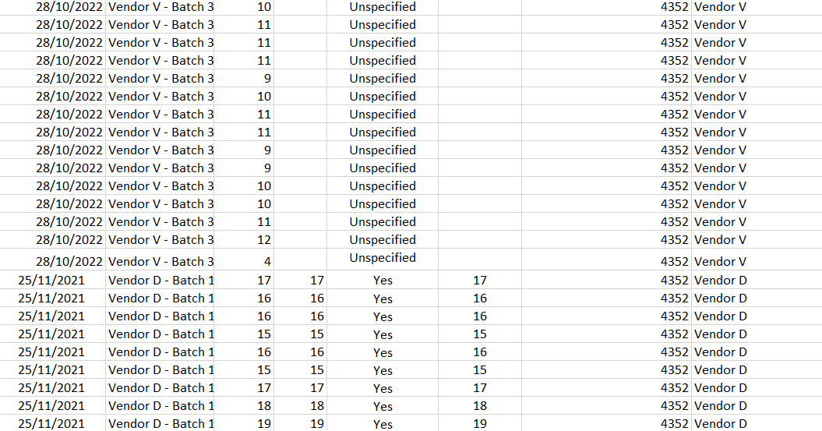

Agency 31
Due to the two unique types of records present, Vendor S and Vendor D, they will be split into two separate sheets, being Agency 31_Vendor S and Agency 31_Vendor D for easier editing. They will be all merged again at the end of this section.
Agency 31_Vendor S
- Removed “DDoc Issue(s)”, “Additional Remarks”, “Remarks”, “Received/Returned DDoc Volume”, “Start/End Date”, “Box/Envelope”, “Agency” and “Month” columns.
- Readded the “Proj.DDoc volume” column.
  - For consistency, this value will also repeat in the Agency_31_Vendor D file.
- Added a “Category” column which specifies their label of data. In this case, it is “Scan Hub”.
- In the “Sample Checked” column, fixed a few values where instead of “Yes”, “1” was written instead. This is reasonable enough to change, as its remarks mention all received files being returned.
- Added a new column, "Batch Category" which filters through “EB”, “WT” or “Unspecified” within the "Batch" column.

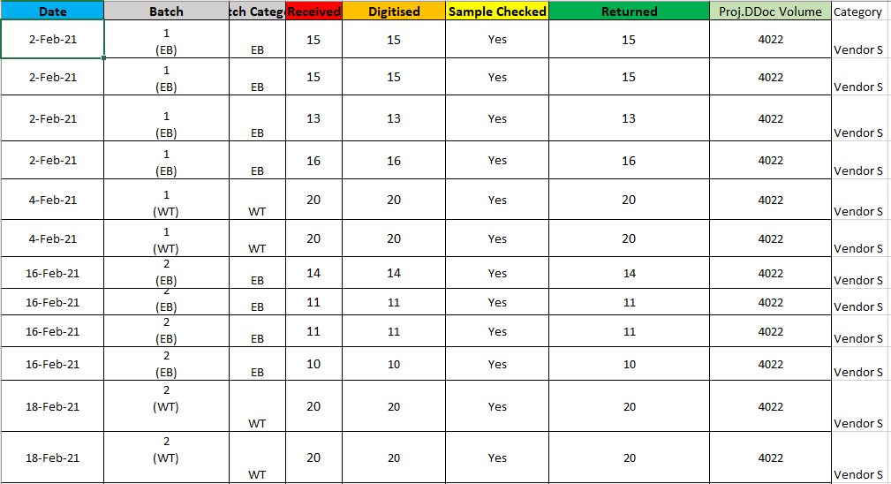
Agency 31_Vendor D
- Removed “DDoc Issue(s)”, “Additional Remarks”, “Remarks”, “Received/Returned DDoc Volume”, “Start/End Date”, “Box/Envelope”, “Agency” and “Month” columns.
- Readded the “Proj.DDoc volume” column.
- Added “Unspecified” to empty “Sample Checked” rows.
- Added a “Category” column which specifies their label of data. In this case, it is “Vendor D”.
- Added a new column, "Batch Category" which filters through “EB”, “WT” or “Unspecified” within the "Batch" column.
After
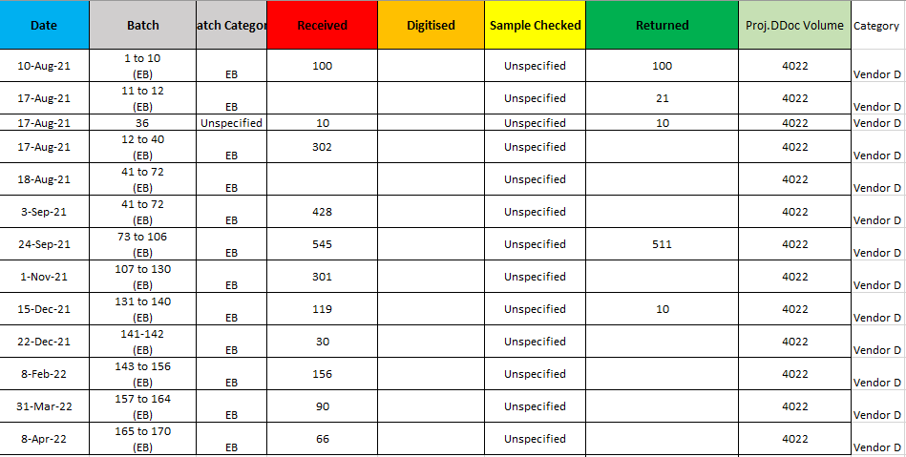

Final Merged Version
This screenshot is to confirm that all datasets have been merged in the “Agency 31” sheet, as shown in the rightmost column that contains all categories (Vendor S and Vendor D)
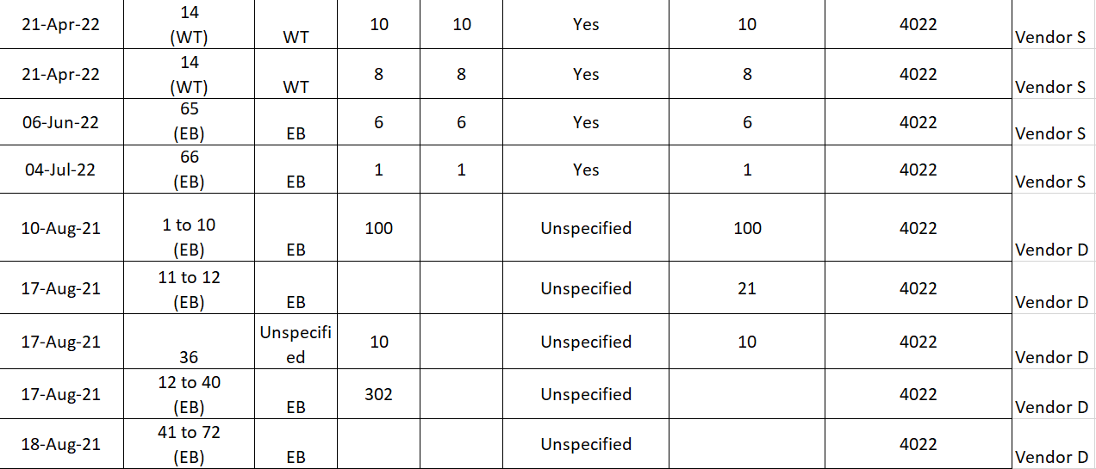
Agency 30
- Removed “DDoc Issue(s)”, “Additional Remarks”, “Remarks”, “Received/Returned DDoc Volume”, “Start/End Date”, “Box/Envelope”, “Agency” and “Month” columns.
- Unmerged “Date” and “Batch” columns.
- Readded the “Proj.DDoc volume” column.
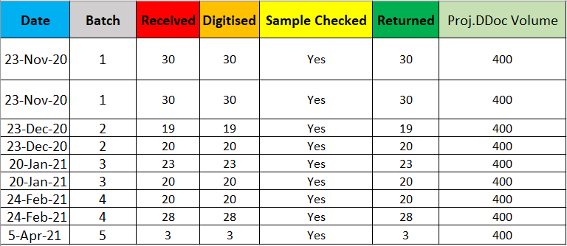

Agency 29
Due to the two unique types of records present, Vendor P and Vendor C, they will be split into two separate sheets, being Agency 29_Vendor P and Agency 29_Vendor C for easier editing. They will be all merged again at the end of this section.
Agency 29_Vendor P
- Removed “DDoc Issue(s)”, “Additional Remarks”, “Remarks”, “Received/Returned DDoc Volume”, “Start/End Date”, “Box/Envelope”, “Agency” and “Month” columns.
- Unmerged “Date” and “Batch” columns.
- Readded the “Proj.DDoc volume” column. It is a value of 400, as shown in the original merged sheet.
- Added “Unspecified” to empty “Sample Checked” rows.
- In the “Digitised” column, as the column needs to be composed of integers for consistency, move all “ongoing” values to a new column, called “Digitised Is Ongoing”.
  - Any row with “ongoing” in the original “Digitalised” column will be set to “Yes” in the new column. Otherwise, it will be displayed as “No”.
- Added a “Category” column which specifies their label of data. In this case, it is “Vendor P”.
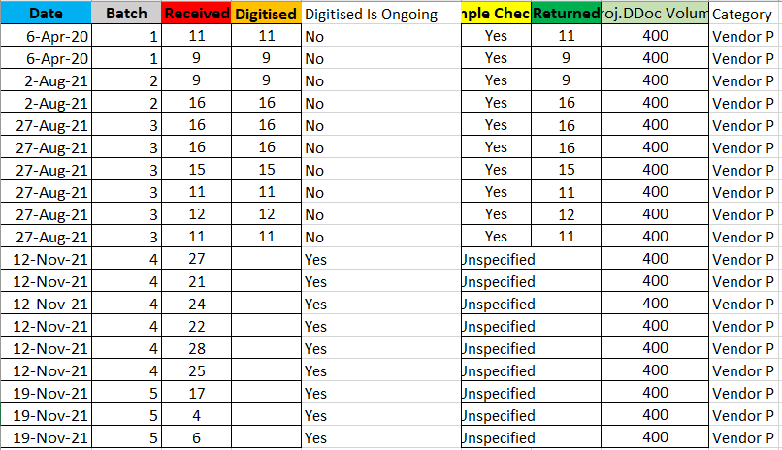

Agency 29_Vendor C
- Removed “DDoc Issue(s)”, “Additional Remarks”, “Remarks”, “Received/Returned DDoc Volume”, “Start/End Date”, “Box/Envelope”, “Agency” and “Month” columns.
- Unmerged “Date” and “Batch” columns.
- Readded the “Proj.DDoc volume” column. It is a value of 300, as shown in the original merged sheet.
- Added “Unspecified” to empty “Sample Checked” rows.
- In the “Digitised” column, as the column needs to be composed of integers for consistency, move all “ongoing” values.
  - The “ongoing” values are moved to a new column, called “Digitised Is Ongoing”.
  - Any row with “ongoing” in the original “Digitalised” column will be set to “Yes” in the new column. Otherwise, it will be displayed as “No”.
- Added a “Category” column which specifies their label of data. In this case, it is “Vendor C”.
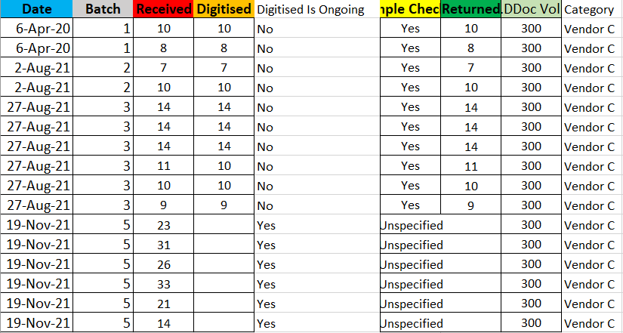
Final Merged Version
This screenshot is to confirm that all datasets have been merged in the “Agency 29” sheet, as shown in the rightmost column that contains all categories (Vendor P and Vendor C)
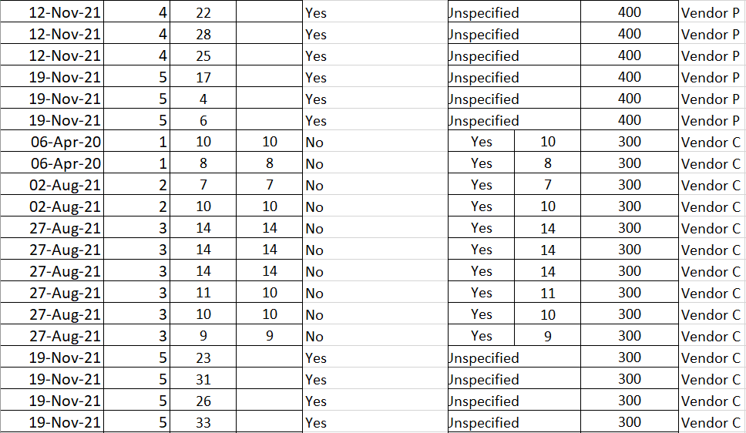

Agency 28
- Removed “DDoc Issue(s)”, “Additional Remarks”, “Remarks”, “Month”, “Box/Envelope”, “Start/End Date”, “Agency” and “Received/Returned DDoc Volume” columns.
- Unmerged “Date” and “Batch” columns.
- Readded the “Proj.DDoc volume” column.
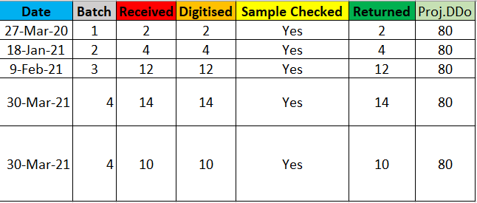

Agency 27
- Removed “DDoc Issue(s)”, “Month”, “Box/Envelope”, “Start/End Date”, “Agency”, “Received/Returned DDoc Volume”, “Additional Remarks” and “Remarks” columns.
- Unmerged the “Batch” and “Date” column.
- Readded the “Proj.DDoc volume” column.
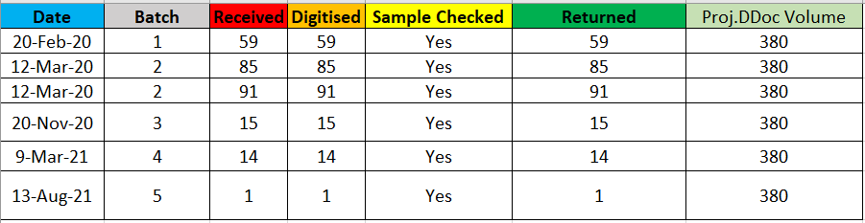
Agency 26
- Removed “DDoc Issue(s)”, “Box/Envelope” and “Additional Remarks”, “Month”, “Remarks”, “Agency”, “Start/End Date” and “Received/Returned Volume” columns.
- Unmerged “Date” and “Batch” columns.
- Readded the “Proj.DDoc volume” column.
- Added “Unspecified” to empty “Sample Checked” rows.
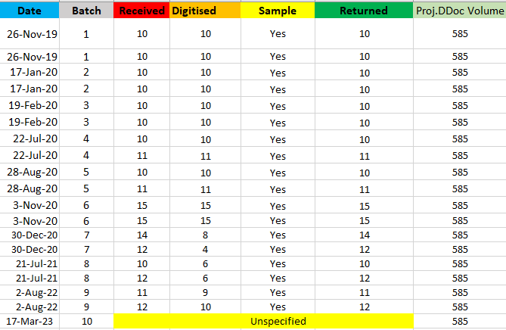

Agency 25
- Removed “Month”, “Box/Envelope”, “DDoc Issue(s)”, “Additional Remarks”, “Agency”, “Start/End Date”, “Received/Returned DDoc Volume” and “Remarks” columns.
- Unmerged “Date” and “Batch” columns.
- Readded the “Proj.DDoc volume” column.
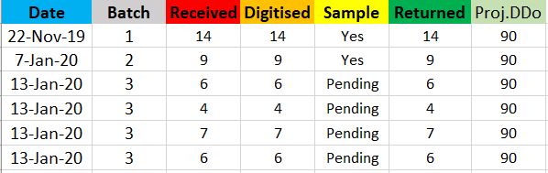
Agency 24
- Removed “Month”, “DDoc Issue(s)”, “Additional Remarks”, “Box/Envelope”, “Remarks”, “Agency”, “Start/End Date” and “Received/Returned DDoc Volume” columns.
- Readded the “Proj.DDoc volume” column.
- Unmerged the “Batch” and “Date” columns.
- Deleted empty rows in-between.
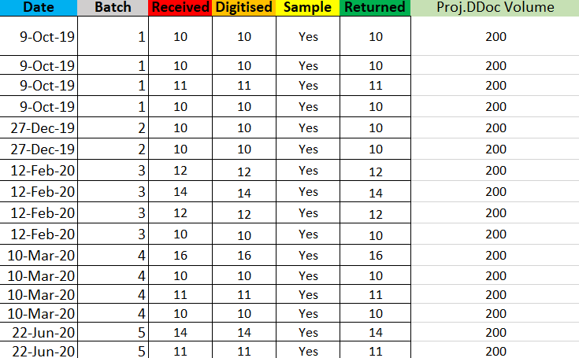

Agency 23
- Removed “Month”, “DDoc Issue(s)”, “Additional Remarks”, “Box/Envelope”, “Remarks”, “Agency”, “Start/End Date” and “Received/Returned DDoc Volume” columns.
- Readded the “Proj.DDoc volume” column.
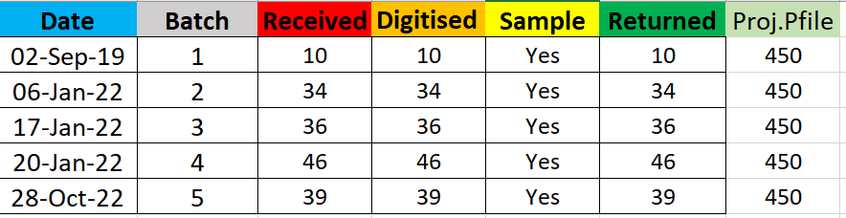
Agency 22
- Removed “Month”, “DDoc Issue(s)”, “Additional Remarks”, “Box/Envelope”, “Remarks”, “Agency”, “Start/End Date” and “Received/Returned DDoc Volume” columns.
- Readded the “Proj.DDoc volume” column.
- Unmerged “Date” and “Batch” column.
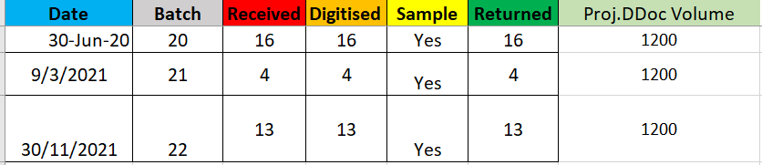
Agency 21
Due to the two unique types of records present, Vendor S and Vendor D, they will be split into two separate sheets, being Agency 21_Vendor S and Agency 21_Vendor D for easier editing. They will be all merged again at the end of this section.
Agency 21_Vendor S
- Removed “Month”, “DDoc Issue(s)”, “Additional Remarks”, “Box/Envelope”, “Remarks”, “Agency”, “Start/End Date” and “Received/Returned DDoc Volume” columns.
- Readded the “Proj.DDoc volume” column.
  - For consistency, this value will also repeat in the Agency 21_Vendor D file.
- Since we do not know the contents of each Received/Digitised/Returned files individual Box/Envelope per batch, (49 in the first row spanning over 1 of 5 and 2 of 5 etc, instead of 10, 10, 10, 10 and 9 etc), we will simply unmerge this cell and delete the extra cell(s) below, leaving behind only 1.
- Unmerged “Date” and “Batch” columns.
- Added “Unspecified” to the empty “Sample Checked” column.
- Copied cells from the “Received”/”Digitised” rows to “Returned” with matching numbers. For example, in Batch 4, we copy all individual values within the “Received” data to the “Returned” column as both columns add up to 62 within the batch.
- Added a “Category” column which specifies their label of data. In this case, it is “Vendor S”.
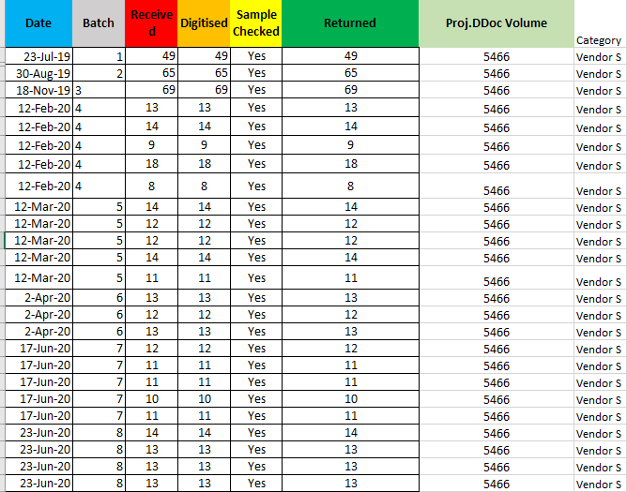
Agency 21_Vendor D
- Removed “Month”, “DDoc Issue(s)”, “Additional Remarks”, “Box/Envelope”, “Remarks”, “Agency”, “Start/End Date” and “Received/Returned DDoc Volume” columns.
- Readded the “Proj.DDoc volume” column.
- Added a “Category” column which specifies their label of data. In this case, it is “Vendor D”.
- Unmerged “Date” and “Batch” columns.
- Added “Unspecified” to the empty “Sample Checked” column.

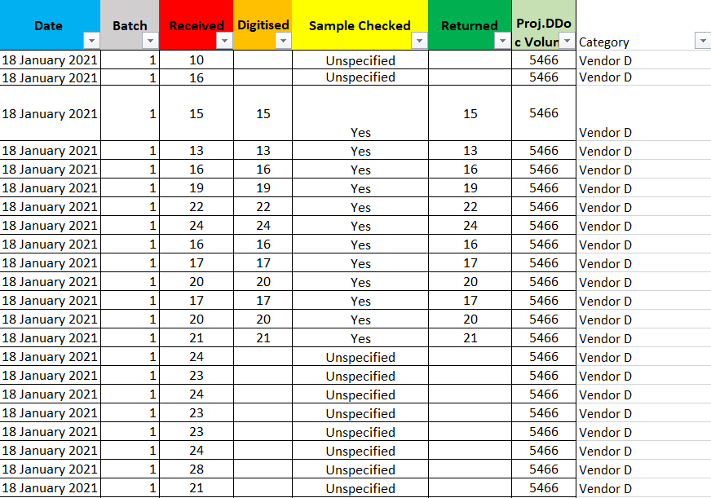
Final Merged Version
This screenshot is to confirm that all datasets have been merged in the “Agency 21” sheet, as shown in the rightmost column that contains all categories (Vendor S and Vendor D)
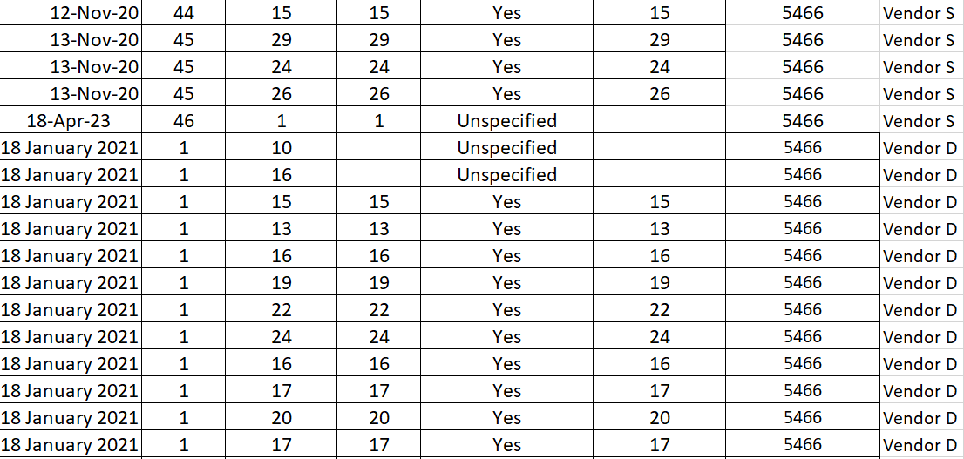

Agency 20
- Removed “Month”, “DDoc Issue(s)”, “Additional Remarks”, “Box/Envelope”, “Remarks”, “Agency”, “Start/End Date” and “Received/Returned DDoc Volume” columns.
- Since we do not know the contents of each Received/Digitised/Returned files individual Box/Envelope per batch, (13 in the first row spanning over 1 of 2 and 2 of 2 instead of 10 and 3, 8 and 5, etc), we will simply unmerge this cell and delete the extra cell(s) below, leaving behind only 1.
- Unmerged “Date” column.
- Readded the “Proj.DDoc volume” column.
- Due to the mix of integers and strings in the “Digitised” column, created a new column called “Digitised Status”.
  - Values in the “Digitised” column with the same amount of received documents have a value of “Complete”. Otherwise, “Pending” and “Ongoing” values are kept here instead.
- Added “Unspecified” to empty cells within the “Sample Checked” column.
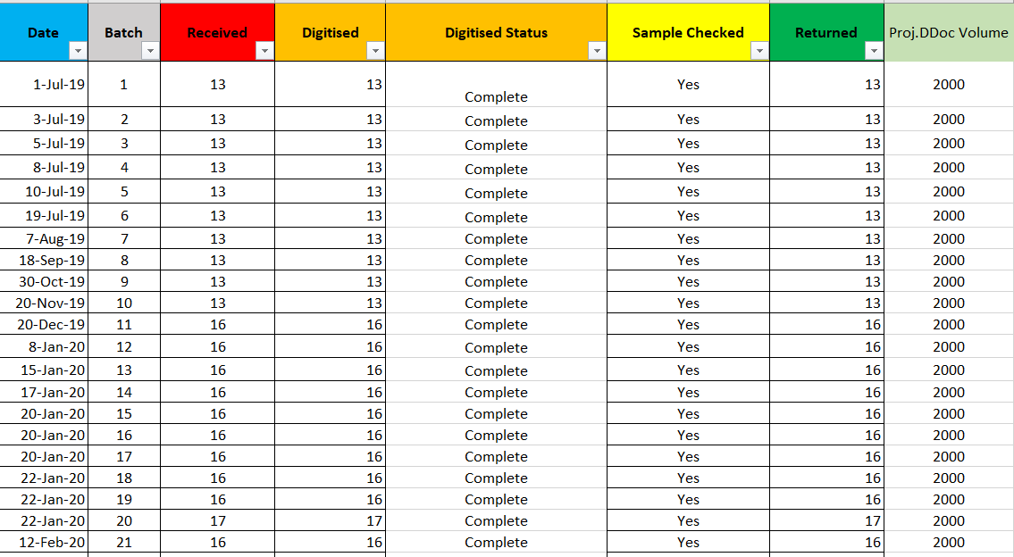

Agency 19
- Removed “Month”, “DDoc Issue(s)”, “Additional Remarks”, “Box/Envelope”, “Remarks”, “Agency”, “Start/End Date” and “Received/Returned DDoc Volume” columns.
- Unmerged “Date” column.
- Readded the “Proj.DDoc volume” column.
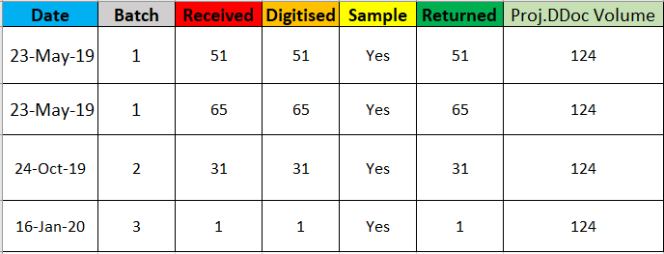
Agency 18
- Removed “Month”, “DDoc Issue(s)”, “Additional Remarks”, “Box/Envelope”, “Remarks”, “Agency”, “Start/End Date” and “Received/Returned DDoc Volume” columns.
- Unmerged “Date” and “Batch” columns column.
- Readded the “Proj.DDoc volume” column.
- Added “Unspecified” to the empty “Sample Checked” column.
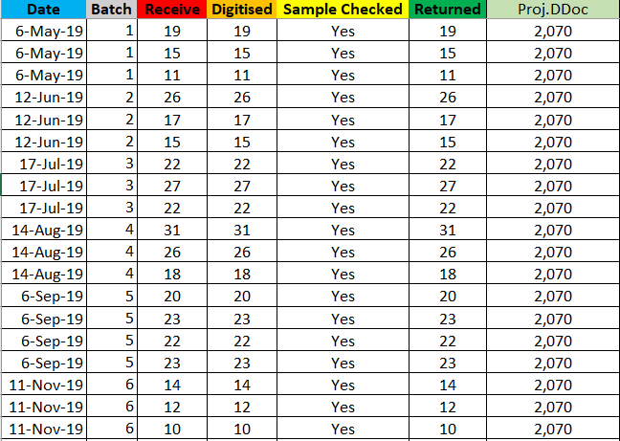

Agency 17
- Removed “Month”, “DDoc Issue(s)”, “Additional Remarks”, “Box/Envelope”, “Remarks”, “Agency”, “Start/End Date” and “Received/Returned DDoc Volume” columns.
- Readded the “Proj.DDoc volume” column.
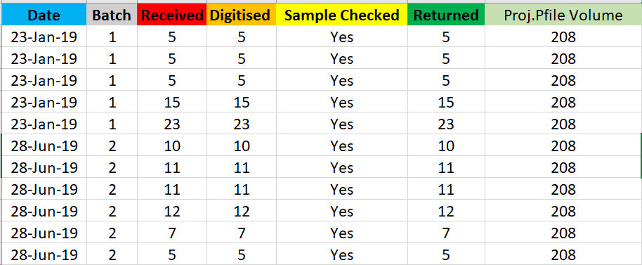
Agency 16
- Removed “Month”, “DDoc Issue(s)”, “Additional Remarks”, “Box/Envelope”, “Remarks”, “Agency”, “Start/End Date” and “Received/Returned DDoc Volume” columns.
- Readded the “Proj.DDoc volume” column.
- Capitalized “ongoing” into “Ongoing” for consistency in the “Sample Checked” column.
- Added “Unspecified” in empty “Sample Checked” cells.
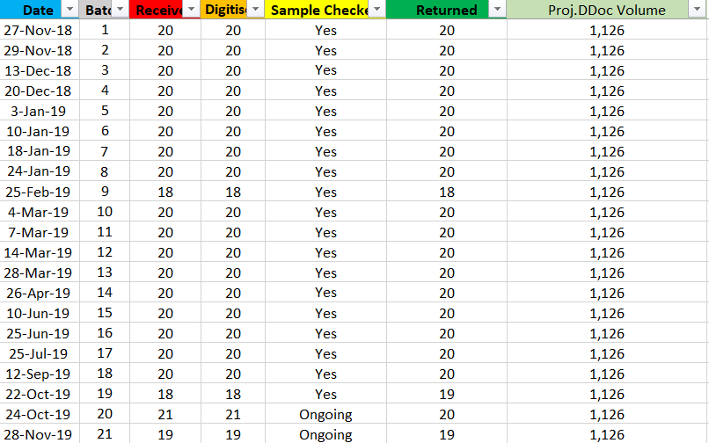

Agency 15
- Removed “Month”, “DDoc Issue(s)”, “Additional Remarks”, “Box/Envelope”, “Remarks”, “Agency”, “Start/End Date” and “Received/Returned DDoc Volume” columns.
- Readded the “Proj.DDoc volume” column.
- Unmerged the “Date” column.
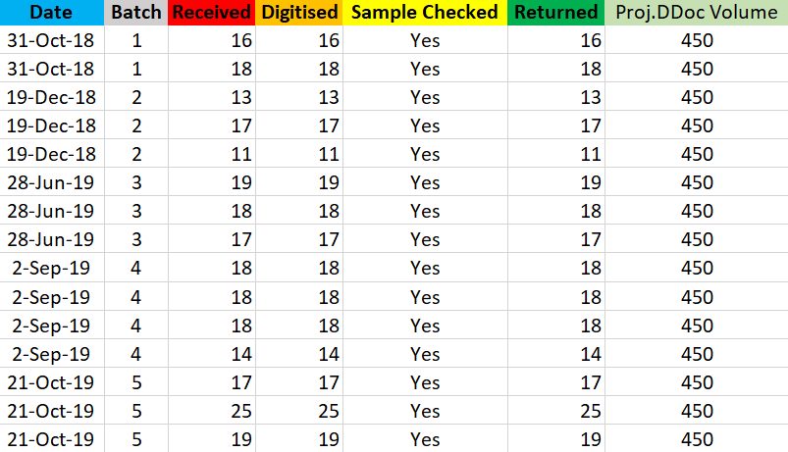
Agency 14
Due to the two unique types of records present, Vendor S and Vendor D, they will be split into two separate sheets, being Agency 14_Vendor S and Agency 14_Vendor D for easier editing. They will be all merged again at the end of this section.
Agency 14_Vendor S
- Removed “Month”, “DDoc Issue(s)”, “Additional Remarks”, “Box/Envelope”, “Remarks”, “Agency”, “Start/End Date” and “Received/Returned DDoc Volume” columns.
- Since we do not know the contents of each Received/Digitised/Returned files individual Box/Envelope per batch, (10 spanning over 1 of 3, 2 of 3 etc, instead of 2, 5, 3 etc), we will simply unmerge this cell and delete the extra cell(s) below, leaving behind only 1.
- Unmerged the “Date” and “Batch” columns.
- Added a “Category” column which specifies their label of data. In this case, it is “Vendor S”.
- Readded the “Proj.DDoc volume” column.
  - For consistency, this value will also repeat in the other file.
- Added “Unspecified” to empty “Sample Checked” cells.

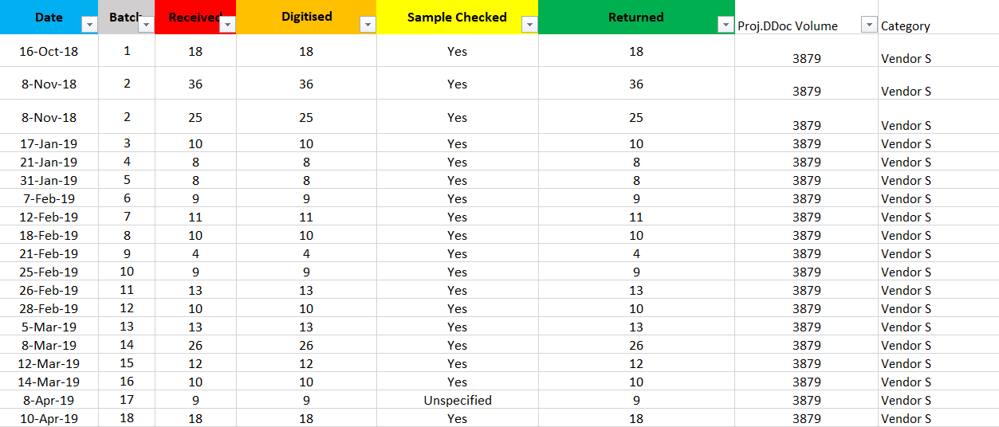
Agency 14_Vendor D
- Removed “Month”, “Box/Envelope” and “Remarks” columns.
- Added “Unspecified” to empty “Sample Checked” cells.
- Added a “Category” column which specifies their label of data. In this case, it is “Vendor D”.
- Readded the “Proj.DDoc volume” column.
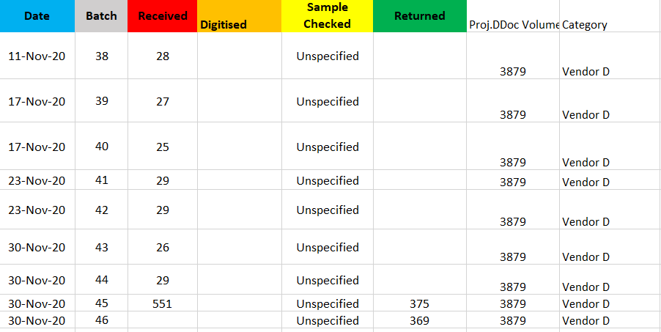

Final Merged Version
This screenshot is to confirm that all datasets have been merged in the “Agency 14” sheet, as shown in the rightmost column that contains all categories (Vendor S, Vendor D)
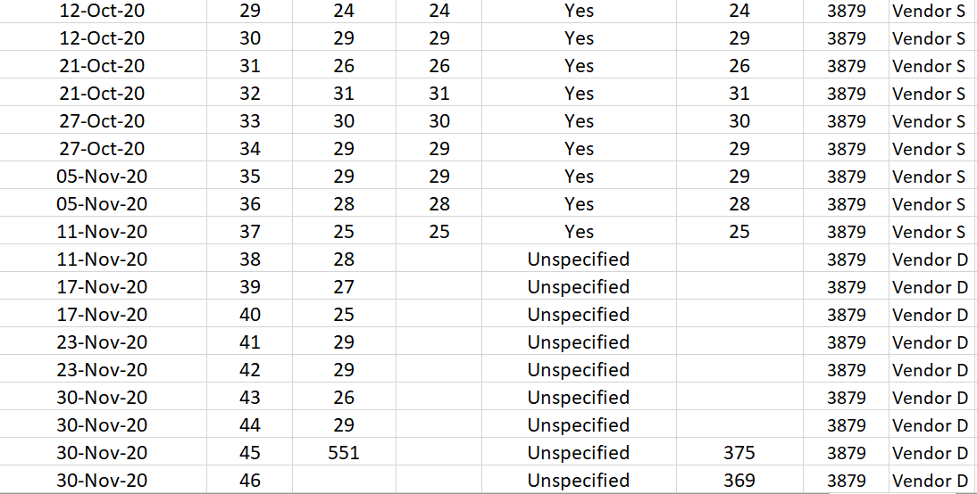

Agency 13
- Removed “Month”, “DDoc Issue(s)”, “Additional Remarks”, “Box/Envelope”, “Remarks”, “Agency”, “Start/End Date” and “Received/Returned DDoc Volume” columns.
- Readded the “Proj.DDoc volume” column.
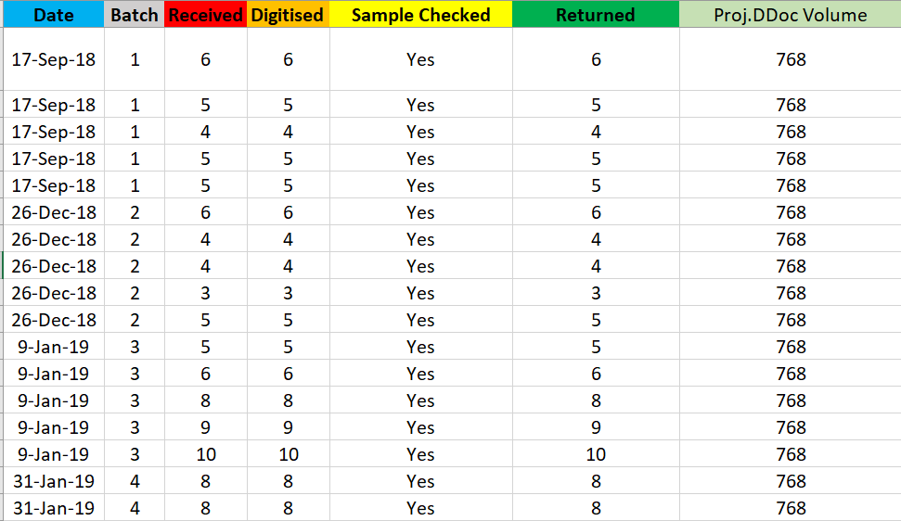
Agency 12
- Removed “Month”, “DDoc Issue(s)”, “Additional Remarks”, “Box/Envelope”, “Remarks”, “Agency”, “Start/End Date” and “Received/Returned DDoc Volume” columns.
- Readded the “Proj.DDoc volume” column.
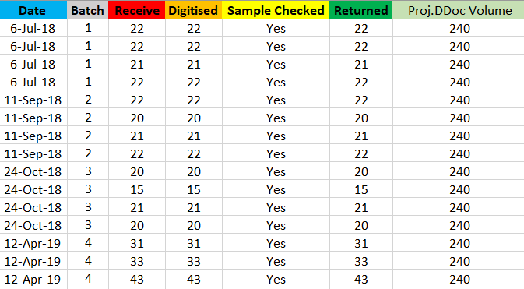
Agency 11
- Removed “Month”, “DDoc Issue(s)”, “Additional Remarks”, “Box/Envelope”, “Remarks”, “Agency”, “Start/End Date” and “Received/Returned DDoc Volume” columns.
- Readded the “Proj.DDoc volume” column.
- Unmerged the “Batch” and “Date” column, as well as a cell in the “Returned” column, with a value of 74. It is split based on their respective values of 34 and 40 within the “Received/Digitised” columns.
- Capitalized the “p” in “pending” in “Sample Checked” for consistency.
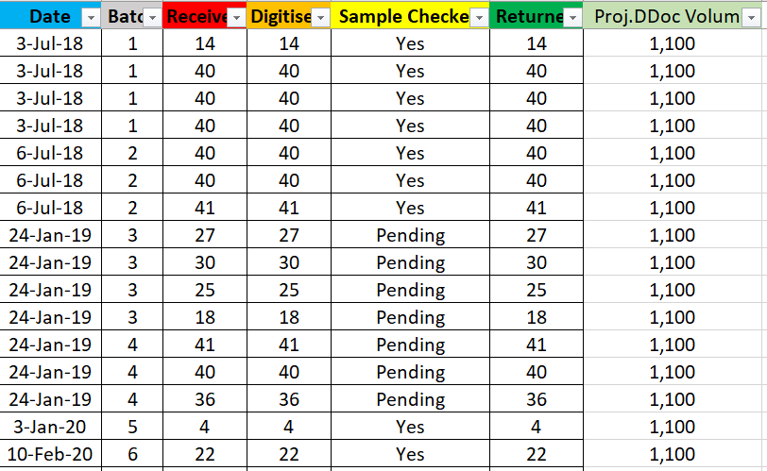
Agency 10
- Removed “Month”, “DDoc Issue(s)”, “Additional Remarks”, “Box/Envelope”, “Remarks”, “Agency”, “Start/End Date” and “Received/Returned DDoc Volume” columns.
- Readded the “Proj.DDoc volume” column.
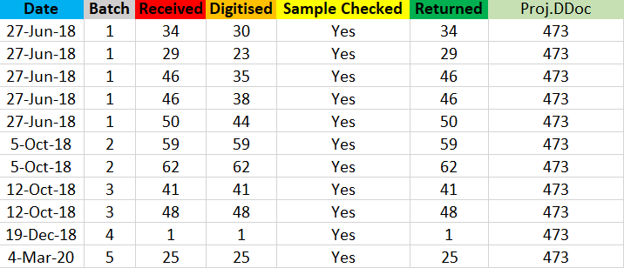
Agency 9
- Removed “Month”, “DDoc Issue(s)”, “Additional Remarks”, “Box/Envelope”, “Remarks”, “Agency”, “Start/End Date” and “Received/Returned DDoc Volume” columns.
- Readded the “Proj.DDoc volume” column.
- Unmerged the “Batch” and “Date” columns.
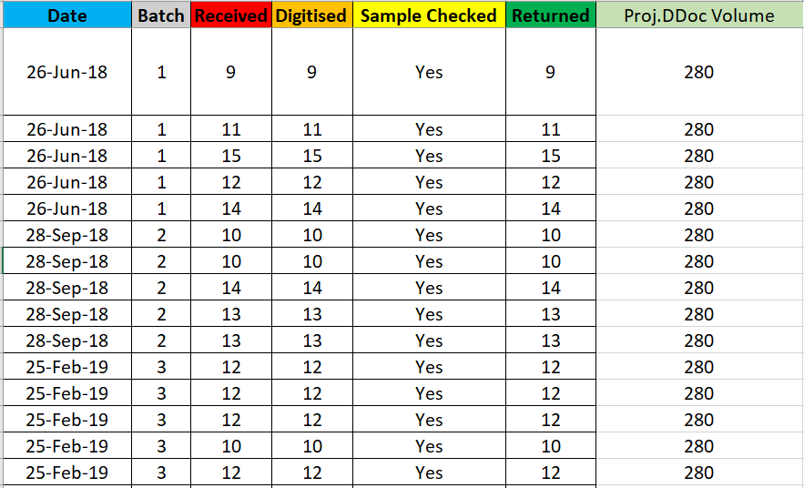

Agency 8
- Removed “Month”, “DDoc Issue(s)”, “Additional Remarks”, “Box/Envelope”, “Remarks”, “Agency”, “Start/End Date” and “Received/Returned DDoc Volume” columns.
- Readded the “Proj.DDoc volume” column.
- Unmerged the “Batch” and “Date” columns.
- Added “Unspecified” to empty “Sample Checked” cells.
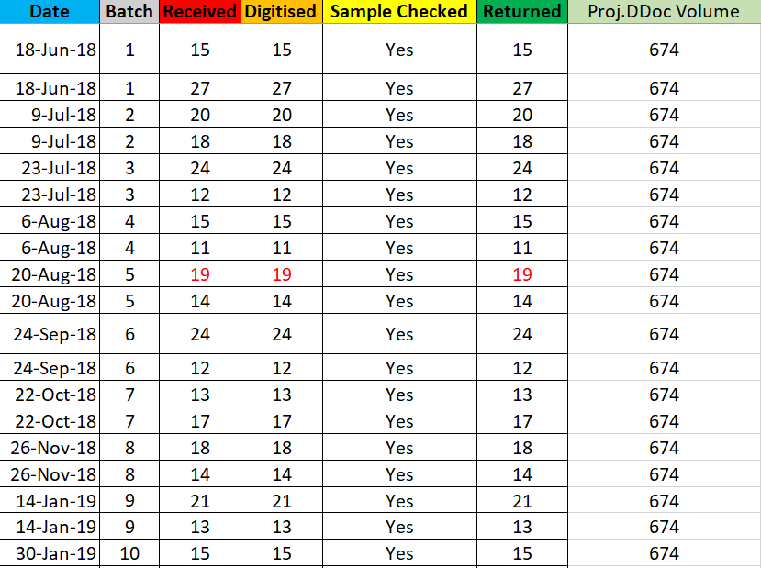

Agency 7
- Removed “Month”, “DDoc Issue(s)”, “Additional Remarks”, “Box/Envelope”, “Remarks”, “Agency”, “Start/End Date” and “Received/Returned DDoc Volume” columns.
- Readded the “Proj.DDoc volume” column.
- Unmerged the “Batch” and “Date” columns.
- Changed “pending” to “Pending” in the “Sample Checked” column.
- Added “Unspecified” to the empty “Sample Checked” cells.
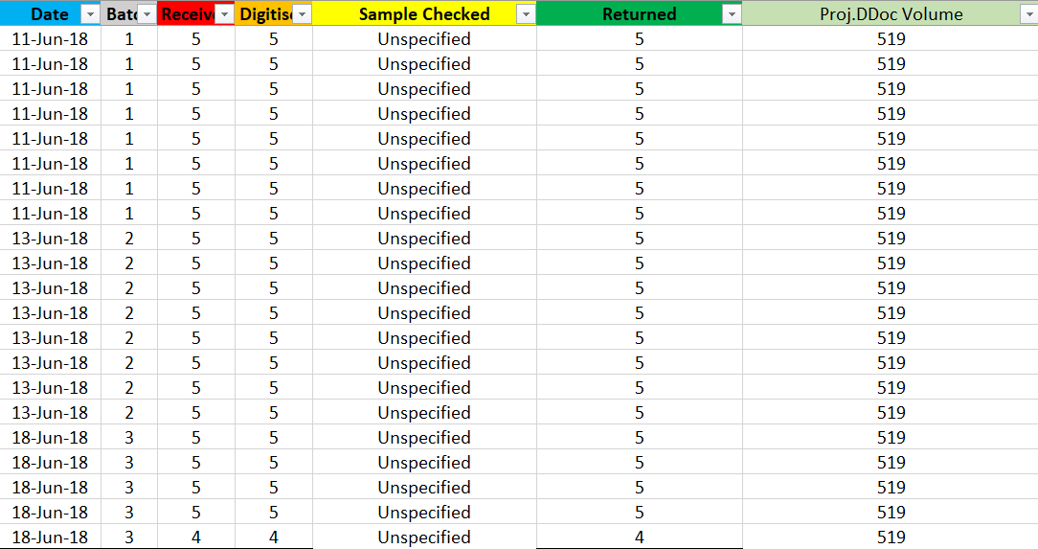
Agency 6
- Removed “Month”, “DDoc Issue(s)”, “Additional Remarks”, “Box/Envelope”, “Remarks”, “Agency”, “Start/End Date” and “Received/Returned DDoc Volume” columns.
- Readded the “Proj.DDoc volume” column.
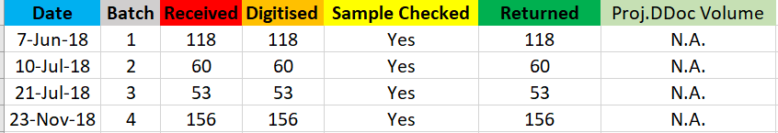

Agency 5
- Removed “Month”, “DDoc Issue(s)”, “Additional Remarks”, “Box/Envelope”, “Remarks”, “Agency”, “Start/End Date” and “Received/Returned DDoc Volume” columns.
- Readded the “Proj.DDoc volume” column.
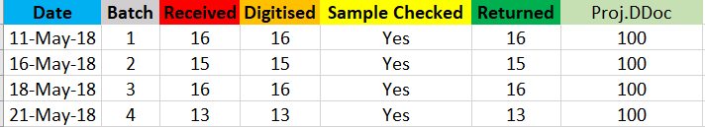
Agency 4
- Removed “Month”, “DDoc Issue(s)”, “Additional Remarks”, “Box/Envelope”, “Remarks”, “Agency”, “Start/End Date” and “Received/Returned DDoc Volume” columns.
- Readded the “Proj.DDoc volume” column.
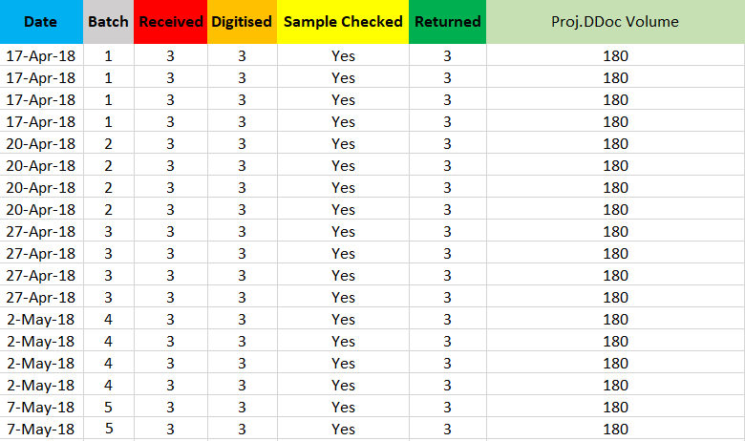

Agency 3
- Removed “Month”, “DDoc Issue(s)”, “Additional Remarks”, “Box/Envelope”, “Remarks”, “Agency”, “Start/End Date” and “Received/Returned DDoc Volume” columns.
- Readded the “Proj.DDoc volume” column.
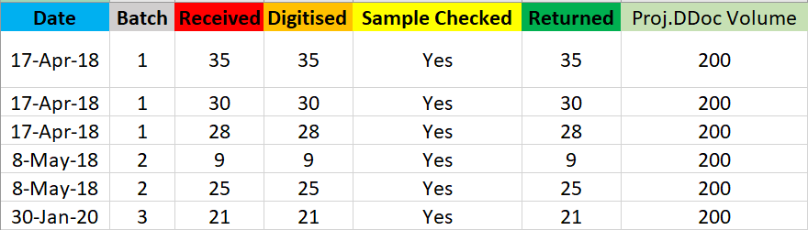
Agency 2
- Removed “Month”, “DDoc Issue(s)”, “Additional Remarks”, “Box/Envelope”, “Remarks”, “Agency”, “Start/End Date” and “Received/Returned DDoc Volume” columns.
- Readded the “Proj.DDoc volume” column.
- Unmerged the “Sample Checked” column.
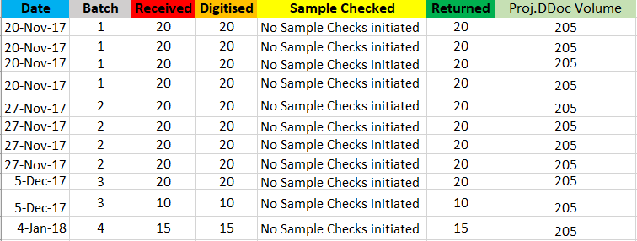

Agency 1
- Removed “Month”, “DDoc Issue(s)”, “Additional Remarks”, “Box/Envelope”, “Remarks”, “Agency”, “Start/End Date” and “Received/Returned DDoc Volume” columns.
- Removed the “Date” column due to it having completely blank data.
- Readded the “Proj.DDoc volume” column.
- Unmerged the “Sample Checked” column.
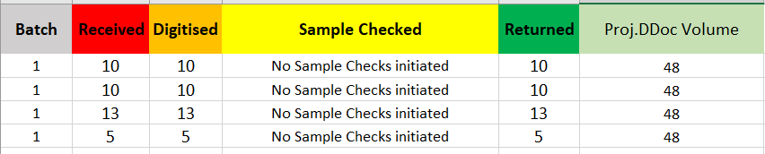
Agency 0
Due to the initial two unique types of records present, Vendor S and Vendor D, they will be split into two separate sheets, being Agency 0_Vendor S and Agency 0_Vendor D, for easier editing. They will be all merged again at the end of this section.
There’s also a third unnamed type of record present, which is not considered when calculating the total number of documents for neither Vendor S nor Vendor D. This will be labelled as Agency 0_Others.
Agency 0_Vendor S
Even if Vendor S has only 1 row present, it is still distinct enough to have its own dataset.
- Removed “Month”, “DDoc Issue(s)”, “Additional Remarks”, “Remarks”, “Agency”, “Start/End Date”, “Received/Returned DDoc Volume” and “Number of Box” columns.
  - “Number of Box” is essentially “Box/Envelope” which is not being used as analysis.
- Readded the “Proj.DDoc volume” column.
  - For consistency, this value will also repeat in the other two files.
- Added a value of “07/01/2021” in the “Date” column, as the value is blank there. We use the value after it in the original dataset.
- Added a “Sample Checked Values Match” column. As the “Sample Checked” in previous datasets is usually a string value instead of an integer, this newly added column checks if the “Sample Checked” value contains the same number of values to the Received and Digitised columns.
- Added a “Category” column which specifies their label of data. In this case, it is “Vendor S”.

Agency 0_Vendor D
- Removed “Month”, “DDoc Issue(s)”, “Additional Remarks”, “Remarks”, “Agency”, “Start/End Date”, “Number of Box” and “Received/Returned DDoc Volume” columns.
- Readded the “Proj.DDoc volume” column.
- Added a “Sample Checked Values Match” column.
- Added a “Category” column which specifies their label of data. In this case, it is “Vendor D”.
- Fixed a date incorrectly titled as “2/5/8/22”, now labelled as “25/8/2022”.
- Readded missing dates as shown in these cells marked in bold. The dates of the previous cell were used. (Shown in the photo below)
Bolding of Dates
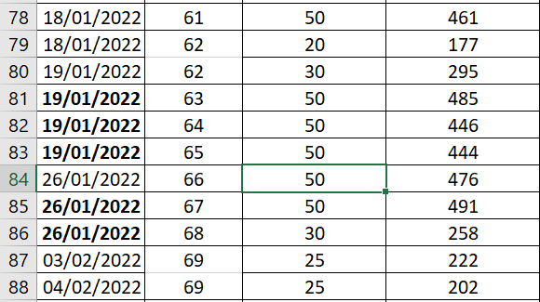
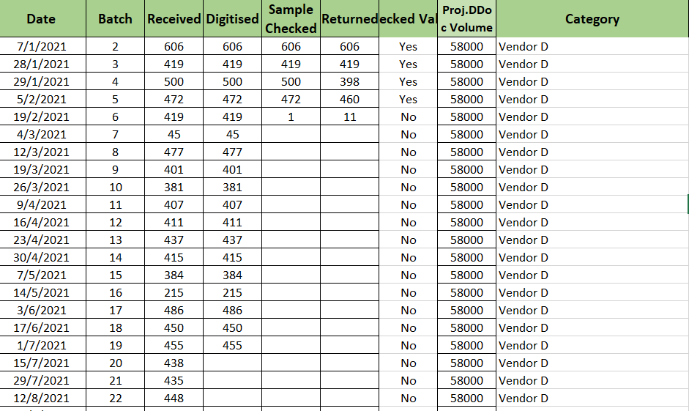

Agency 0_Others
- Removed “Month”, “DDoc Issue(s)”, “Additional Remarks”, “Remarks”, “Agency” and “Start/End Date” and “Number of Box” columns.
- Readded the “Proj.DDoc volume” column.
- Added “Unspecified” to empty “Sample Checked” rows.
- Added the “Sample Checked Values Match” column.
- Readded the “Proj.DDoc volume” column.
- Added a “Category” column which specifies their label of data. In this case, it is “Others”.
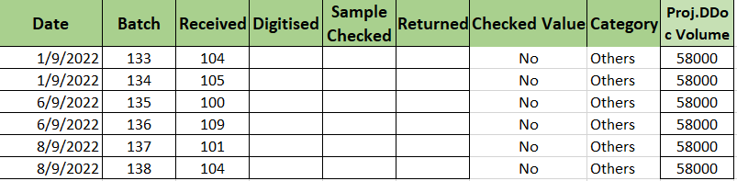
Final Merged Version
This screenshot is to confirm that all datasets have been merged in the “Agency 0” sheet, as shown in the rightmost column that contains all categories (Vendor S, Vendor D and Others)
